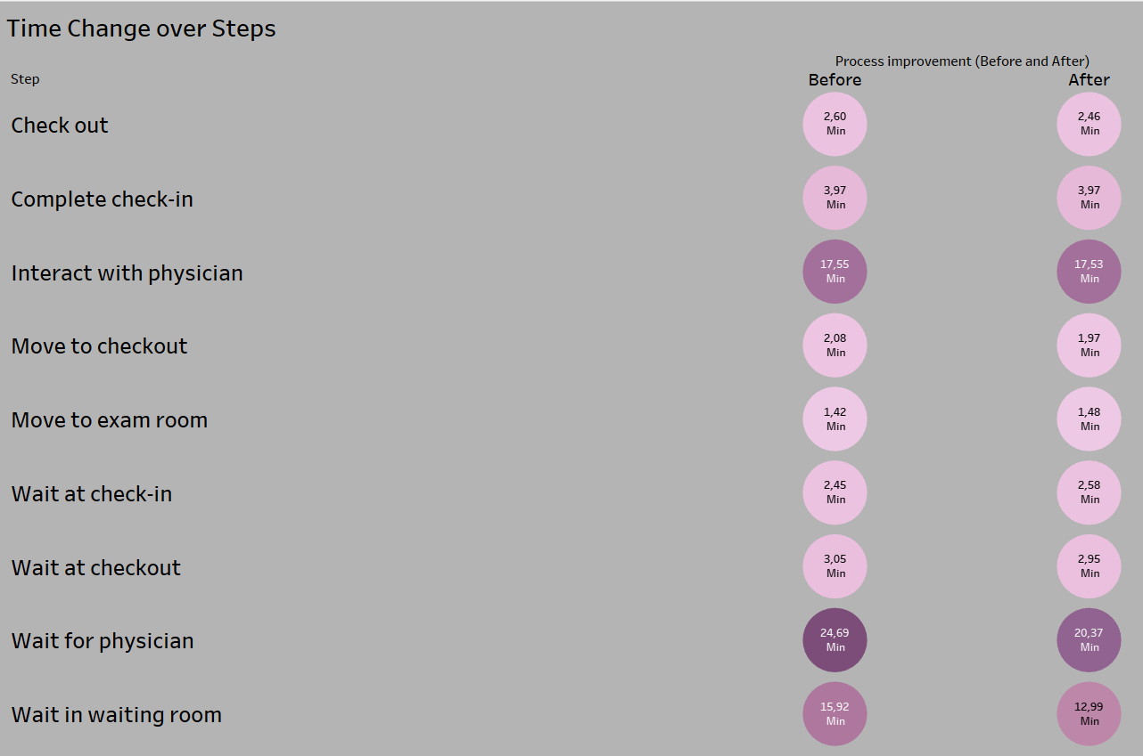

This visualization shows the average time values before and after the improvement program. Thanks to the colors, you can see the critical time spent by the patient for a certain step. And although some changes were insignificant, it can be seen how in the key moments of waiting for the doctor and in the room, the time significantly decreased, therefore, the improvement program coped with its task.

At the next visualization, thanks to the colors, they reflect the total amount of time that patients spend waiting for the doctor and in the waiting room, since the number of dark shades prevails after the implementation of the program, it is possible that the General Practitioner (GP) department has a significant decrease in the total time, the other two departments have huge increase in the total time that the patient spends waiting. And on this visualization, we see that before the implementation of the program, patients spent much less time than after. Which indicates the need to improve the program.

Moving on to the next imaging, I used a separate sample of patients aged 26 to 29, as well as the specialist department, as this facilitates more accurate analysis. In this rendering, the shades are distributed according to steps and start from lighter to darker, as well as steps from first to last. And you can see that a lot of light and dark shades are located high up, which indicates a significant improvement in average time thanks to the program.

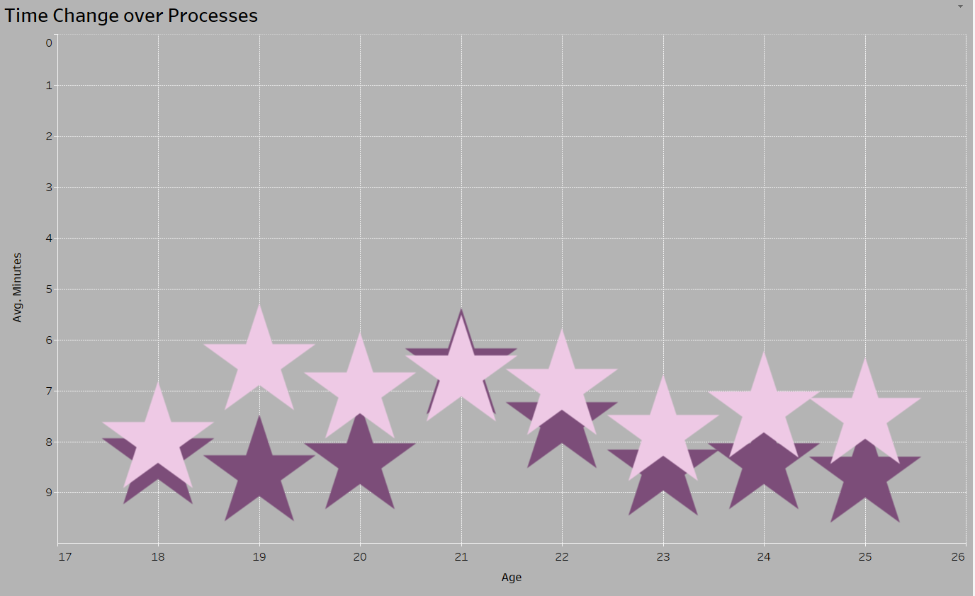

The last visualization shows the average time before and after the enhancement program. Pink stars this time after the program and burgundy before. And we can see that this sample of 8 samples has improvements in 7 cases out of 8, which indicates that the program is working effectively.

For this visualization, black was used to clearly highlight the moments at which the care score was highest. And here there is a direct connection between the waiting time and the care score. And my first recommendation is to come up with the most optimal approach to latency and find a way to reduce it.

In the next visualization, the shade of the stars indicates how high the score care was given to a particular department. And we can single out the departments with ratings below 3 since this means that the quality of these departments does not suit patients. Therefore, my second recommendation is to optimize the work of those score care departments which are 3 and below.

This visualization shows the average time per Admit Source and Type, and the darker the shade, the longer it takes. So, my final recommendation is to focus on Elective, Outside Health Care Facility, for better future performance.